Shimna
Integrated College
Specialist School

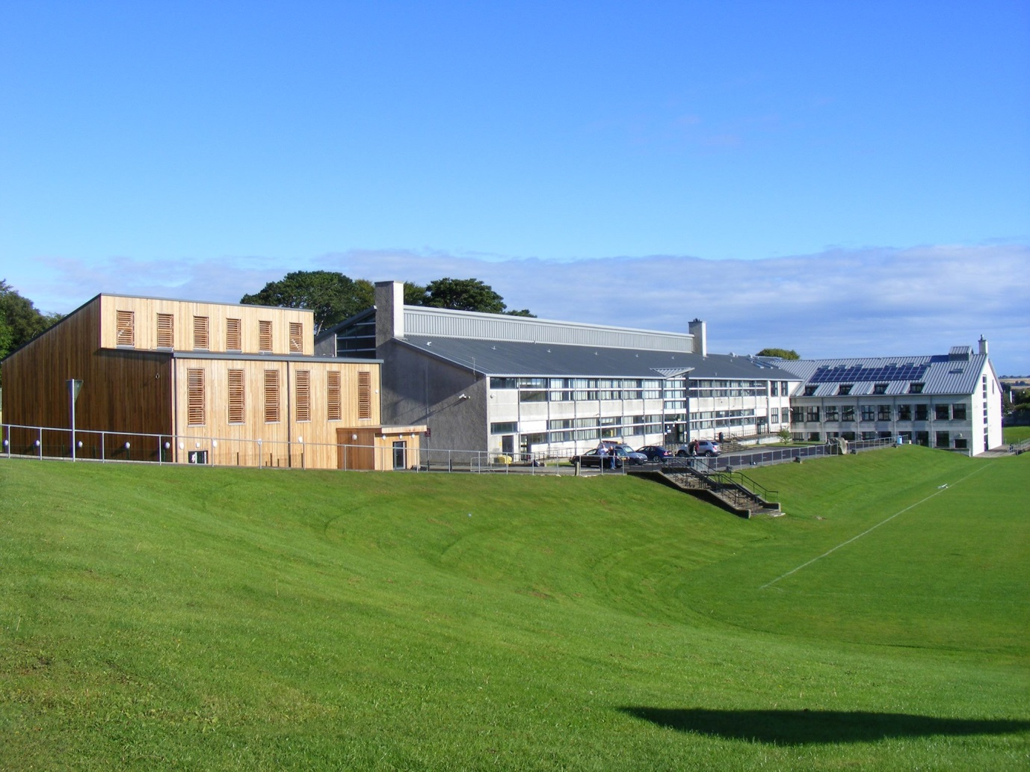

Annual Report of
The Board of Governors 2017/2018

Shimna is a Grant Maintained Integrated College
Contents

Foreword…………………………………………………………………….3

Agreed Statements of Shimna Integrated College…………………………..4

Board of Governors 2016/2017 ……………………………………………..5

Functions of the Board of Governors……………………………………….6 - 7

The Board of Governors and Sub-Committees …………………………….8 - 13

- Staffing Committee Report

- Discipline Committee Report

- Estates Committee Report

- Education Committee Report

- Finance & Audit Committee Report

- Shimna Integrated College – Draft Income & Expenditure Account……14

Draft Balance Sheet ……………………………..15
Notes to the Financial Statements ……………….16 - 18

FOREWORD
I am pleased to publish this Annual Report for Shimna Integrated College for the academic year 2017-2018.
In so many areas we have had a very successful year. Despite the very difficult financial situation that all schools find themselves in we have achieved outstanding successes not only among our students who excelled in recent GCSE and A levels but also in our staff who have had much success in the literacy, numeracy and scientific fields. Success is due in no small measure to the hard work of students and the dedication of our very professional staff.
The Board of Governors supports the work of the principal and staff in the areas of admissions, discipline, education, estates, finance and staffing. All of the governors have attended child protection training in October 2017 and pastoral care issues are very much at the centre of all our decisions. Governors have also attended training programmes relevant to their specific committee and we thank all of them who give of their time so freely for the good of the college.
We welcome to our teaching staff this year the following members – Ms Lorna Jess (science), Ms Catherine Owens (English) and Mr Barry Dagan (PE) and hope they will have a happy and successful time in our college.
Our links with the community continue to grow and the college has been involved in projects from YMCA, Acti-sport, Unit T Beach Clean, Shimna Shooters Netball, Rainbow, Guides and Brownies, Mourne School of Dance and the Habitat for Humanity group. Our students proved themselves very worthy participants in a television programme with Paddy Kielty to commemorate the Good Friday Agreement which was broadcast by the BBC
Plans are at an initial stage for the construction of a new building for Shimna College and although this may be some way off we are very excited about this project.
Our financial situation has again been a real source of worry both for governors and the principal and we continue to make cut backs whilst retaining our commitment for the best education for our students. We very much appreciate the help we have received this year from the EA officer Angels Evans who has been a great help in getting us through the year with the minimum of deficit.

Anne Fitzpatrick
Chairperson

AGREED STATEMENTS OF SHIMNA COLLEGE
The Statements below were agreed by the Workshop of Founder Parents of the Newcastle Integrated College Project on 2nd October 1993 and shall be the Guiding Principles for the College.

- We are committed to having a minimum of 40 percent of each of the two main traditions in the college.

- The college cannot be truly integrated unless children of all abilities are encouraged to attend.

- Care must be taken to avoid discrimination not only on the grounds of religion but also sex, class and culture, physical or mental ability.

- The college will be most effective in terms of academic learning, behaviour and attendance if it works closely with parents and welcomes parental involvement.

- All cultures / religious groups within the college shall be valued equally.

- Children shall be placed in mixed ability classes for the first year. After the first year, the children shall remain in the same form class, but will be taught for some subjects in similar ability groups.

- The aim of the college is to enable each and every child to realise his or her maximum potential; be it academic, creative, or vocational; and to flourish in personal development and self-esteem.

- We are committed to the establishment of a sixth form which will be in place for the 1994 intake of students. This sixth form will continue to cater for all abilities.

- The children shall learn together all that we can reasonably expect them to learn together.

- Children will be introduced to the ideas, beliefs and practices of the major world religions and humanist philosophies, in addition to studying an agreed core Christian religion syllabus.

- Local religious leaders will be invited to the college on certain occasions to share in the life of Shimna.

- Children of parents who do not wish them to follow the religion syllabus shall be given proper alternative provision.

- Special care will be taken at assemblies in the selection of texts and music. Children shall be encouraged to continue with their normal practice, such as The Lord's Prayer and making the sign of the cross.

Board of Governors
Shimna Integrated College 2017/18

Trust Foundation Governors – 2 x 4 Years
Vacancy
Anne Fitzpatrick
Geraldine Graham
Deborah Skillen

Parent Foundation Governors – 2 x 4 Years
Patricia Quinn
Catherine Greene

Parent Governors – 1 x 4 Year
Suzanne Murphy Manganaro
Fiona O’Connor
Allyson Cockfield
Rachel Corrigan

DE Governors - 2 x 4 Years
Vacancy
Vacancy
Trevor Henderson
David O’Flaherty

Teacher Governors – 1 x 4 year
Grace Susay
Alasdair Spence

Support Staff Governor – 1 x 4 year
Vacancy

Principal
Kevin Lambe

Secretary
Danella Goodman

Functions of the Board of Governors

The functions of the Board of Governors are clearly shown in the Scheme of Management for Grant Maintained Integrated Schools, a copy of which may be inspected in the college office. Below is a summary of the main functions of the Board of Governors.

1 General

The Board of Governors shall manage and control the college for which it is appointed in accordance with the Scheme of Management.

The Board of Governors shall use its best endeavours to ensure that the management, control and ethos are such as are likely to attract to the college reasonable numbers of both Protestant and Roman Catholic pupils.

The Board of Governors shall reasonably support the principal in such matters as is reasonably necessary to enable him to control the internal organisation, management and discipline of the college.

They shall provide the principal with such opportunities as may be necessary to enable him to express his opinions and to make his recommendations to the Board of Governors on all matters connected with the college including the appointment and removal of non-teaching staff.

2 Financial Management

The Board of Governors shall ensure that the grants available to the college are managed in accordance with the Financial Memorandum and any other conditions determined by the Department and any guidance issued by the Department and NICIE.

3 Staff Management

The Board of Governors shall be responsible for the determination of the college’s staffing complement and for the selection, appointment, remuneration, discipline, suspension and dismissal of all staff employed by the Board of Governors for the purposes of the college.

The Board of Governors in consultation with the principal shall determine the procedures to be used for the selection and appointment of staff.

4 Admission of Pupils to College

The Board of Governors shall exercise its functions in relation to making arrangements for the admission of pupils to college.

5 Determination of Curriculum Policy and of the Curriculum

The Board of Governors shall determine, and keep under review, its policy in relation to the curriculum of the college. It shall make and keep up to date a written statement of that policy.

The Board of Governors shall consult the principal of the college before making or varying any statement in the written policy.

The Board of Governors shall allocate to the principal such functions as will, subject to the resources available, enable him to determine and organise the curriculum in accordance with the curriculum policy for the college.

6 Communication

The Board of Governors shall encourage the principal to promote regular communication between assistant teachers and parents of pupils.

The Board of Governors shall encourage the principal to maintain regular communication and consultation with the assistant teachers on the management of the college, curricular matters and on matters relating to the education, health and welfare and discipline of the pupils.

The Board of Governors shall from time to time request a report from the principal on these matters.

7 Annual Report of the Board of Governors

The Board of Governors shall once in every college year prepare a report in respect of the previous college year.

8 College Inspections

Before each general inspection of the college takes place, the Board of Governors shall convene a meeting for the purpose of enabling the Board of Governors and the parents of registered pupils at the college, to make their views about the college known to the Inspection Team.

After each general inspection of the college, the Board of Governors shall provide the parents of all registered pupils at the college with a summary of the findings in the general inspection report and a copy of the Board of Governors response to the inspection report.

9 Other Reports and Returns

The Board of Governors shall provide for the Education Authority, the Department of Education or Northern Ireland Council for Integrated Education any information, reports and returns as may reasonably be requested.

10 College Premises

The college premises shall be under the control of the Board of Governors at all times.

The Board of Governors shall from time to time and not less than once each year inspect the premises and equipment of the college and shall record its findings.

The Board of Governors and its Committees

Board meetings were held in accordance with the requirements of the Department of Education (DE) and the college’s Scheme of Management. As is common in any school year, the Board dealt with correspondence; heard the principal’s and sub-committee reports and approved their recommendations; handled issues pertaining to the Board; responded to requests from the DE and the Northern Ireland Council for Integrated Education (NICIE) for information; and approved the college’s audited accounts.

The Board’s committees continued to provide opportunities for extended debate and discussion of matters pertaining to, for example, policy, staffing, finance and the curriculum. Each of the main committees meeting on at least four occasions; the Admissions and Discipline Committees met as required.

The committees and chairs for the past year were:
- Finance: Anne Fitzpatrick
- Estates: David O’Flaherty
- Staffing: Deborah Skillen
- Education: Geraldine Graham
- Admissions: Anne Fitzpatrick
- Discipline: Deborah Skillen

The chairs of these committees continue to be grateful to the principal for his attendance at their meetings and for his various and valued contributions.

Staffing Committee – Deborah Skillen
The staffing committee remit, along with the policies for which this committee is responsible, can be viewed on the college website, or can be obtained in printed form from the office. These policies are reviewed on an annual basis and reflect the Department of Education’s guidelines and directives.
Because of the ongoing crisis within our own Government and the uncertainty with all schools budgets it was decided early on in the school year to combine both Staffing and Finance committees. This allowed difficult decisions to be made that affected both committees. The joint committee met on four formal occasions throughout the year.
The committee has responsibility for priorities set out in the College Development Plan. We ended our current development plan at the end of last term. The areas the Staffing committee was responsible for were -
Number 3 – Teaching and Learning
Number 4 – Leadership in Departments and by Co-Ordinators.
We discuss and get an update on the school development plan from the principal at every formal staffing meeting. This year will see the start of a new Shimna Integrated College Development Plan.
The staffing committee has a responsibility to ensure the principal has the opportunity to update his own professional development. Governors have specific training to allow them to undertake this and we also are lucky enough to have an experienced external assessor who knows the college well and has an understanding of the needs of Shimna.
This year has been another difficult one for all Shimna Staff and the Board of Governors. Because of the unfortunate position of our own government bodies and the very clear lack of financial guidance and provision for the school, we have again needed to find ways to save and create financial stability for the school. We have been fortunate to have had help from the Education Authority, enabling us to source funds that have been due to the school and help us to maintain our staffing structure.
There have been some changes within our staffing structure, but his year we have not had to make compulsory redundancies. We have had one member of staff who asked for voluntary redundancy.
The staffing committee would like to thank the staff at Shimna for their continued support and we must acknowledge the fact that many of them are working above and beyond what should be expected of them as teachers. They are all working under extreme pressures to ensure the curriculum is delivered in the best and fullest way possible.
Staff are working hard with students and parents to ensure the day to day running of the school is a smooth as possible, and the staffing committee must congratulate Kevin Lambe (Principal), Karen Caulfield (VP), teaching and non-teaching staff and of course students for their on-going commitment and support in these difficult times.
Discipline Committee – Deborah Skillen
The Discipline Committee met on 2 formal occasions this year. This committee is structured in such a way that they can meet as often as required at the request of the principal. The full discipline committee remit can be found on the college website or can be obtained in paper form from the office at the college.
As always Shimna operates a positive approach to the discipline policy and staff work very hard individually and as team members to develop behaviour plans when required and coping mechanisms, with the aim of creating a calm and productive working ethos within the school.
Here at Shimna we are always happy and proud to share reports from people outside of the school, who comment on our students’ behaviour. Newcastle is a very busy town in and out of holiday season, with visitors from far and wide and the positive feedback we receive especially in relation to courtesy and politeness is always good not only for our students and staff to hear but also has a positive effect with recruitment of new students,
The discipline committee is primarily there to support the principal Kevin Lambe with his decisions on the day to day discipline of students and to ensure that the legal requirements in relation to discipline, suspension and expulsion are adhered to. During our discipline meetings Kevin gives us a comprehensive report on any discipline matters that he or his staff have had to deal with. These are always reported to us in the strictest confidence. However any cases of suspension or serious misconduct including the need for expulsion are brought to a formal discipline committee meeting and discussed in detail. This will be the only time members of the committee will be told students details. Fortunately, at Shimna these meeting are few and far between.
The discipline committee would like to congratulate the principal, vice-principal, teaching and non-teaching staff and of course our wonderful students for their commitment and hard work whilst keeping Shimna an inspiring, happy, safe place to work and be educated.
Estates Committee - David O’Flaherty
Inspections and Audit
Two routine inspections took place during the year. These highlighted a number of issues on a general maintenance level. All have been dealt with satisfactorily. All faults reported have been dealt with by our premises manager, Robbie Mulholland. Any requests for improvements have been duly noted.
The College Development Plan was discussed throughout the year, specifically with regard to the expected increase in the college population in the coming years. The college has now secured funding for a new build for the school on the sports pitch with use of Donard Park for outdoor sports.
The photo voltaic panels installed in 2015 are now well established as an excellent boost to the college’s economy. As there continues to be enormous pressure on the annual budget, any extra source of revenue is highly valued.
The sports hall remains a fantastic asset to the school, accommodating sports, exams and assemblies. This space is also used by a wide variety of groups from the local community.
The cleaning of the college continues to be contracted out to a cleaning company, Service Master. This contract started in August 2016. It is working well for the college in practical terms.
Accessibility
Each phase of our building was designed with disabled access in mind, and governors continue to take into account any proposals that would improve the college’s access arrangements. We continue to operate an evacuation procedure on the advice of the local Northern Ireland Fire & Rescue Service, and have set aside and labelled two refuge points in low risk areas, in order to ensure the safe evacuation of wheelchair users in the event of an emergency.
Security
We are confident that our site is relatively secure, due to its setting away from through traffic. Our main gate remains open throughout the day, and arrangements are in place for the back gate which balances the safety needs of our students and the safety needs of parents and children walking through our grounds to access All Children’s IPS. Restricting their access would force young children onto a much more dangerous route. Our door access system is now fully operational (on entrance/exit doors) during the school day adding extra security to the school. CCTV is used by the College 24 hours a day.
Conclusion
The college premises manager, Robbie Mulholland, has dealt extremely efficiently with any matters arising from inspections throughout the year, ensuring a safe, comfortable environment for all concerned. The college continues to aim to provide a suitable and uplifting environment for all students and staff.
Education Committee – Geraldine Graham
It was my privilege to take over from Isobel Jones as chair of the Education Committee at the beginning of the academic year.
The Committee met on four occasions throughout the year to deal with priorities including
: Curriculum Development.
: Budget constraints and implications for the curriculum.
: Careers.
: 2017 examination results and attainment targets.
: The college development plans for literacy and numeracy.
We can look back on another year of excellent results with our students progressing to a wide range of universities, further education institutions, apprenticeships and employment opportunities.
Thanks to the commitment of our dedicated staff and the hard work of our students we can look forward to another successful year at Shimna Integrated College.
Performance Indicator | 2014/15 |  | 2015/16 |  | 2016/17 |  | Attendance Rate  2017/18  94.1%
 | School | N.I. Average | School | N.I. Average | School | N.I. Average
% Achieving 5+ GCSEs at Grades A* - C (or equivalent) | 74% | 72% | 72% | 72.7% | 67.1% | 72.7%
% Achieving 2+ A Levels at Grades A – E (or equivalent) | 96% | 95.8% | 95% | 96.1% | 100% | 96.1%

Leaver Destinations June 2018
 | Year 12 Students
 | Returning to Sixth Form at Shimna | 52
 | Further Education | 22
 | Jobskills/Training/Apprenticeship | 3
 | Jobskills at Further Education College | 1
 | Another School (Non-Grammar) | 1
 | Another School (Grammar) | 2
 | Another School (unknown) | 1
 | Elective Home Education | 1
 | Total | 83
 | Year 14 Students
 | Degree Course (N.I.) | 20
 | Degree Course (G.B.) | 21
 | Degree Course (Non U.K.) | 2
 | Further Education | 7
 | Employment | 5
 | Emigrated | 1
 | Total | 56

Finance Committee – Annual Report 2017-2018
The finance committee meets at regular intervals during the year to provide up-to-date financial information to all members of the Board of Governors. The finance committee consists of 3 members of the Board of Governors, the Principal of the College and the College finance officer who is always in attendance to provide additional information or to clarify any queries which may arise. Minutes of all the meetings are kept and provided to the full Board of Governors.
Internal and external audits are carried out and these have again proved to be very satisfactory.
The following is a list of the main activities and developments relating to finance of the college for the school year September 2017 to August 2018.
- This has been another year when the college budget suffered from planned DE funding reduction and as a result measures had to be taken to reduce expenditure
- One member of the teaching staff opted for a voluntary redundancy and this was accepted.
- Our growth has continued and is now fully funded thanks to the work of our EA financial officer Ms Angela Evans
- Money was transferred from Meals and Sundries Accounts during the year to prevent bank charges.
- Governors have been supplied with finance reports providing information on a monthly basis for income and expenditure and all decisions taken in relation to the budget have been ratified through the finance committee.

SHIMNA COLLEGE
INCOME AND EXPENDITURE ACCOUNT
For period ending 31 March 2018

INCOME | 2018  £ | 2017  £
Department of Education grants | 3,300,698 | 3,306,682
Receipts from other sources | 42,571 | 70,122
 | 3,343,269 | 3,376,804
EXPENDITURE
Teaching staff costs | 2,097,878 | 2,017,077
Non-Teaching staff costs | 763,916 | 836,652
Other operating costs | 505,353 | 559,156
 | 3,367,147 | 3,412,885
Deficit for the financial year | (23,878) | (36,081)

BALANCE SHEET
as at 31 MARCH 2018
 | 2018  £ | 2017  £
Fixed Assets
Tangible fixed assets | 3,980,776 | 3,957,364
Current Assets
Debtors | 19,071 | 28,700
Cash at bank and in hand | 33,330 | 19,361
 | 52,401 | 48,061
Creditors: amounts falling due  within one year | (174,880) | (146,662)
Net current liabilities  Total assets less current liabilities  Creditors: amounts falling due  After more than one year | (122,479)  3,858,297  (3,980,776) | (98,601)  3,858,763  (3,957,364)
Net Liabilities | (122,479) | (98,601)
Reserves
Revenue reserves | (122,479) | (98,601)

NOTES TO THE FINANCIAL STATEMENTS

Creditors | 2018  £ | 2017  £
Amounts falling due within one year
Trade creditors | 6,823 | (51)
Other creditors | 131,516 | 141,747
Accruals and deferred income | 36,541 | 4,966
 | 174,880 | 146,662
Other Operating Payments | 2018 | 2017
 | £ | £
Heat, light and power | 51,095 | 54,271
Water charges | 4,736 | 1,661
Laundry and cleaning | 58,273 | 42,051
Rates | 130,436 | 125,924
Maintenance of buildings and grounds | 21,153 | 32,544
Maintenance of equipment | 2,567 | 4,210
Purchase of equipment | 22,670 | 37,741
Hire and contracted services | 9,165 | 3,848
Stationery, books and materials | 36,765 | 43,352
Examination fees | 42,222 | 56,364
School prizes and distribution | 473 | 687
Transport | 9,282 | 10,419
Advertising | 6,529 | 9,943
Printing and stationery | 24,283 | 23,775
Postage & telephone | 10,375 | 11,428
Insurance | 20,269 | 17,513
Audit fees | 4,250 | 4,200
Bank charges | 1,197 | 1,077
Subscriptions and publications | 472 | 1,302
Legal expenses  Entertainment and hospitality | 1,713  292 | 2013  1,349
Staff development | 559 | 1,238
Pupil course fees | 3,165 | 30,299
Sundry expenses  VAT | 3,073  39,300 | 451  40,437
Depreciation | 230,384 | 202,232
Amortisation | (230,384) | (202,232)
 | 505,353 | 559,156
NOTES TO THE FINANCIAL STATEMENTS

Department of Education Grants
 | 2018 | 2017
 | £ | £
Recurrent grant | 3,241,556 | 3,111,506
Other Department of Education grants  VAT grant | 19,842  39,300 | 154,739  40,437
 | 3,300,698 | 3,306,682
Receipts from Other Sources
 | 2018 | 2017
 | £ | £
Other income | 42,571 | 70,122
 | 42,571 | 70,122
Teaching staff costs
 | 2018 | 2017
 | £ | £
Permanent teachers
Gross Pay | 1,580,209 | 1,488,710
Employer’s superannuation | 274,450 | 259,471
Employer’s national insurance | 164,630 | 159,198
 | 2,019,289 | 1,907,379
Substitute teachers
Gross Pay | 56,516 | 76,326
Employer’s superannuation | 9,448 | 6,875
Employer’s national insurance | 4,867 | 13,504
 | 70,831 | 96,705
Foreign language assistants | 7,758 | 12.993
Total teaching staff costs | 2,097,878 | 2,017,077

NOTES TO THE FINANCIAL STATEMENTS

Non-teaching staff costs | 2018 | 2017
 | £ | £
Administration staff | 189,406 | 181,722
Caretaker | 35,641 | 35,701
Cleaners | 19,856 | 43,047
Lunch supervisors | 6,364 | 7,363
Technicians | 109,340 | 100,034
Statemented classroom assistants | 341,195 | 394,821
Non-Statemented classroom assistants | 62,114 | 73,944
 | 763,916 | 836,652
Debtors | 2018 | 2017
 | £ | £
Trade debtors | 7,046 | 354
Other debtors | 12,025 | 28,346
 | 19,071 | 28,700

